LAB Assignment No. 7

LAB Task 1: Next Word Prediction using RNN

Objective:
Learn how RNNs can predict the next word in a sentence. This is a text generation task where the model predicts the next word given the previous context in a sentence.

Steps:
- Load and Clean the Text Data:
First, we will load a sample text (e.g., "Shakespeare.txt") and clean the text (remove punctuation, convert to lowercase, etc.).
- Tokenize and Convert Text into Sequences:
We will tokenize the text and convert the words into sequences of numbers for processing by the RNN.
- Build a Simple RNN Model:
We'll create a simple RNN model with keras.layers.SimpleRNN.
- Train the Model:
Train the model to predict the next word based on the previous 3-5 words.
- Test the Model:
After training, test the model with custom input and get predictions for the next word.

Code Example:
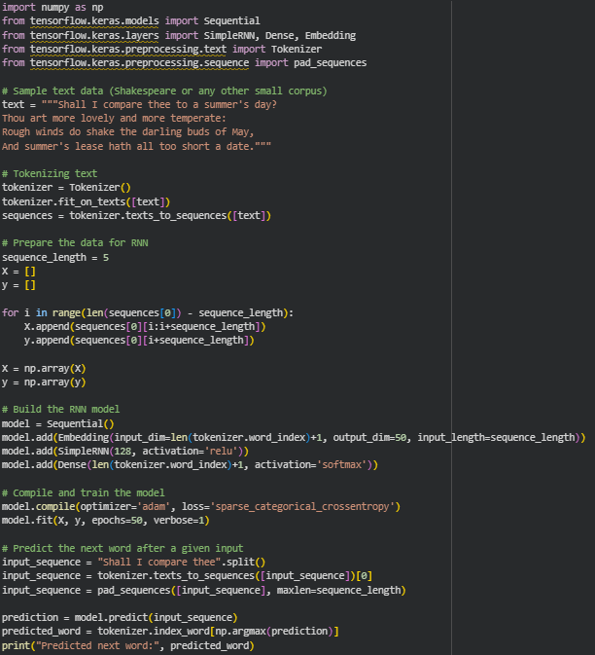
OUTPUT
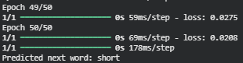

Explanation:
- Tokenizer converts words into sequences of integers.
- Embedding layer represents each word as a dense vector.
- The SimpleRNN layer captures temporal dependencies between words in the sequence.
- Loss function is sparse_categorical_crossentropy as we are predicting a single word from a set of possible words.

LAB Task 2: Stock Price Prediction using RNN

Objective:
Predict future stock prices using time-series data. This task requires predicting stock prices based on historical data using an RNN.

Steps:
- Import Dataset and Normalize Values:
We'll use the Google Stock Price dataset. Normalize the stock prices to be between 0 and 1 using MinMaxScaler.
- Prepare Time-Step Sequences:
Prepare the dataset for RNN training by creating sequences from the past n days to predict the next day.
- Build and Train RNN Model:
Use SimpleRNN layers to model the stock price data.
- Evaluate Predictions vs. Actual Prices:
After training, plot the predicted vs actual prices.

Code Example:
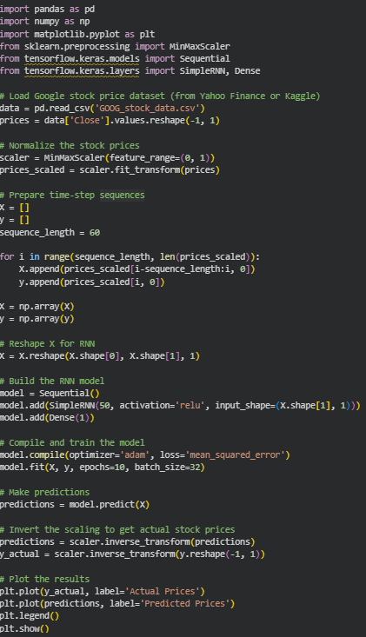

Explanation:
- MinMaxScaler is used to normalize the stock prices to a range between 0 and 1.
- The RNN model is trained to predict the next day's price using the previous 60 days.
- The plot shows the actual vs predicted prices.

LAB Task 3: Sentiment Analysis using RNN

Objective:
Classify movie reviews as positive or negative using RNN.

Steps:
- Load and Preprocess the Dataset:
We use the IMDb dataset, which contains movie reviews and their sentiments (positive/negative).
- Tokenize and Pad Sequences:
We will tokenize the text and pad sequences to ensure that all inputs have the same length.
- Build RNN Model with Embedding Layer:
Use an Embedding layer followed by a SimpleRNN layer for sentiment classification.
- Train and Evaluate the Model:
Train the model on the IMDb reviews and evaluate its performance.

Code Example:
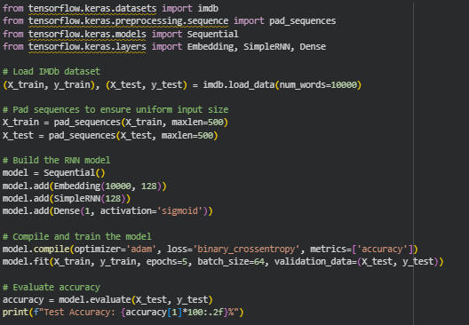

Explanation:
- Embedding layer converts words into dense vectors.
- The SimpleRNN layer captures the sequential dependencies in text.
- Accuracy score tells us how well the model performs in classifying the sentiment of the reviews.

